Chloride consultations media kit

About chloride consultations for faith-based facilities
The goal of the chloride reduction campaign is to decrease the amount of chloride pollution entering Hennepin County (specifically WMWA+RBWMO territory) bodies of water. To accomplish this, public perception must change, and awareness of proper salting practices must increase.
The first major part of this campaign will include engaging faith-based facilities in a one-on-one consultation process to address salt use and improve snow and ice management by providing technical assistance (free of charge).
This campaign is an implementation of the Low Salt, No Salt Minnesota Toolbox. Research done as part of developing this Toolbox indicated that the biggest driver of over-salting is client demand due to fear of slip and fall lawsuits. Education about chloride pollution by itself is often not enough to change winter salting routines. People need to know how to address concerns about safety or liability on their particular property. Additionally, by focusing on facilities that have large populations of stakeholders (e.g. worshippers) the reach of the campaign can be extended and begin to address the overall need to change broad public perception and awareness of winter snow and ice management strategies that are friendly to water resources.

Resources to promote chloride consultations
Ways to educate the public about chloride consultations:
- Use the sample newsletter article to share on your organization’s website or in your newsletters. These are editable so you can customize the length or message.
- Use the sample social media posts to share through your social media channels. These are editable so you can customize the message and website.
- Share this FAQ when applicable.
- Share this flyer when applicable.
- Follow and reshare messages posted on the Hennepin County Environment and Energy social media channels: Hennepin Environment on Facebook, Hennepin Environment on Instagram, and @hennepinenviro on Twitter.
- Share the information and resources available on WMWA’s chloride page.

Contact

For more information about chloride consultations, contact:

Grace Barcelow, Conservation Specialist, grace.barcelow@hennepin.us.
Sample newsletter article – Chloride Consultations

Be a good environmental steward: Reduce salt use at your place of worship

Did you know that one teaspoon of salt pollutes five gallons of water FOREVER? Minnesota’s warm winter has not changed the fact that waterways are being harmed from one of the most worrisome pollutants. When de-icing salt (a.k.a. chloride) enters bodies of water, there is no easy way to remove it. West Metro Water Alliance (WMWA) is a group of city and watersheds in Hennepin County that are working together to improve water quality in partnership with Hennepin County.
One of the biggest threats we face to healthy water systems is pollution from winter de-icing salts when snow and ice melt, and water is washed into storm drains or filtered into groundwater. There is nothing to filter out the salt, and it ends up staying in our world’s water systems… some all the way down the Mississippi to the ocean!
We all want to prioritize safety, but it is critical to understand that more salt does not always mean less ice or safer conditions. Too much salt can lead to costly damages and environmental consequences. Chloride harms plants and animals, contaminates drinking water, damages buildings, and corrodes vehicles, roads, and bridges.
To reduce chloride pollution, here are some simple actions you can take when managing snow and ice this winter:
- Shovel as soon as possible after a snowstorm to prevent ice buildup.
- Add an ice scraper to your toolbox. These are often more effective than salt when ice has built up on sidewalks and driveways.
- Read the label on your deicer to make sure it will properly work in the current weather conditions. At temperatures colder than 15 degrees Fahrenheit, regular road salt will not melt ice.
- Use sand or grit for traction when temperatures are too cold for salt to work.
- Use salt sparingly. Generally, aim to have salt grains dispersed three inches apart.
Additionally, WMWA is offering one-on-one consultations to faith-based facilities in parts of Hennepin County to address salt use and improve snow and ice management, all while keeping communities safe, increasing environmental well-being, and decreasing winter maintenance and infrastructure costs.
If you work with or are a member of a faith-based facility, within the WMWA territory (all or parts of Champlin, Corcoran, Dayton, Maple Grove, Medina, Plymouth, Rogers, Brooklyn Center, Brooklyn Park, Crystal, northern Minneapolis, New Hope, Osseo, Robbinsdale, Golden Valley, Medicine Lake, Minnetonka, St. Louis Park, Richfield, and Bloomington) or are interested in what kind of support you can receive in another watershed, contact Grace Barcelow at grace.barcelow@hennepin.us or 612-543-9295. To see if your property is within WMWA territory search for your property address on the natural resources map (gis.hennepin.us/naturalresources).

Social media posts
Suggested hashtags: #EnvironmentalConservation #Winter #Salt #LowSaltNoSalt #ChloridePollution #CleanWater #Water #WaterQuality
To use images and graphics: right click on image and select Save as Picture

Chloride Pollution
Facebook: Did you know that one teaspoon of salt pollutes 5 gallons of water FOREVER? When de-icing salt (a.k.a. chloride) enters bodies of water, there is no easy way to remove it. Chloride harms plants and animals, contaminates drinking water, damages buildings, and corrodes vehicles, roads, and bridges. To reduce chloride pollution, West Metro Water Alliance (WMWA) is offering one-on-one consultations to faith-based facilities to address salt use and improve snow and ice management, all while keeping communities safe, increasing environmental well-being, and decreasing winter maintenance and infrastructure costs. Learn more at westmetrowateralliance.org/chloride-pollution.
Instagram: Did you know that one teaspoon of salt pollutes 5 gallons of water FOREVER? When de-icing salt (a.k.a. chloride) enters bodies of water, there is no easy way to remove it. Chloride harms plants and animals, contaminates drinking water, damages buildings, and corrodes vehicles, roads, and bridges. To reduce chloride pollution, West Metro Water Alliance (WMWA) is offering one-on-one consultations to faith-based facilities to address salt use and improve snow and ice management, all while keeping communities safe, increasing environmental well-being, and decreasing winter maintenance and infrastructure costs. Learn more at westmetrowateralliance.org/chloride-pollution. #LowSaltNoSalt #EnvironmentalConservation
Twitter: 1 teaspoon of salt pollutes 5 gallons of water FOREVER! Salt harms plants, animals, drinking water, and infrastructure. Request a consultation to learn how your place of worship can reduce salt use and save money at westmetrowateralliance.org/chloride-pollution #LowSaltNoSalt

Image:
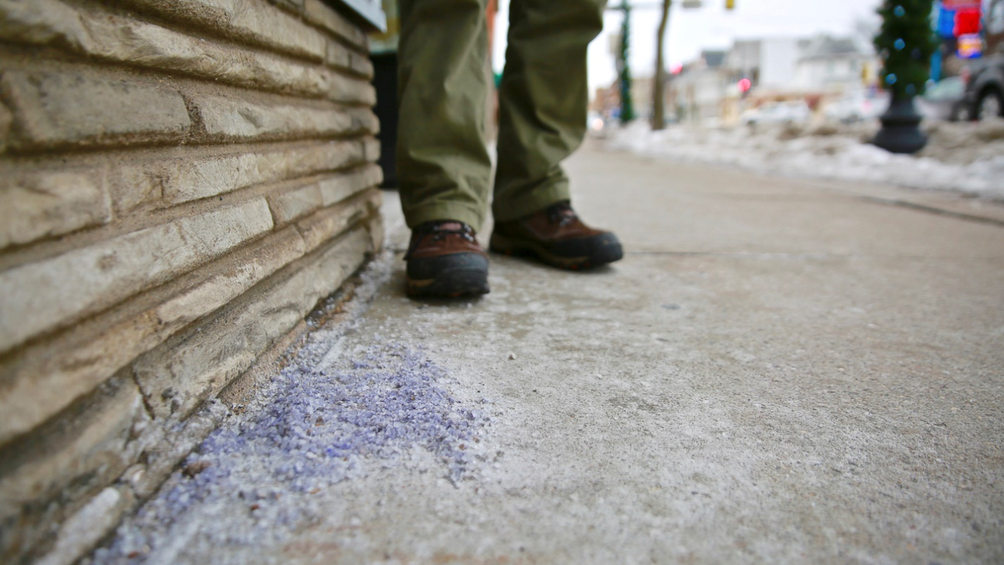
Photo credit: Clean Water MN. Oversalting on sidewalk, next to building.

