Blue Thumb Partnership media kit

Resources to promote planting for clean water
Ways to educate the public about Blue Thumb Resources:
- Use the sample newsletter article to share on your organization’s website or in your newsletters. These are editable so you can customize the length or message.
- Use the sample social media posts to share through your social media channels. These are editable so you can customize the message and website.
- Web links:
  - Blue Thumb: bluethumb.org
  - Resources from Blue Thumb: bluethumb.org/public-resources
  - Workshops and online learning: bluethumb.org/events
  - Plant sales: bluethumb.org/spring-native-plant-sales-in-minnesota
  - Lawns to Legumes: bluethumb.org/lawns-to-legumes/apply
  - Plant Finder: bluethumb.org/plants

Contact
For more information about planting for clean water or the Blue Thumb partnership contact:
Grace Barcelow, Conservation Specialist, grace.barcelow@hennepin.us
Sample newsletter article – Blue Thumb Partnership

Plant your spring gardens to support a resilient, pollinator friendly yard!

As you prepare your yard, plan your gardens, and get new plants this spring, don’t forget to plant for clean water and pollinators! By using proper yard design and planting pollinator-friendly plants, our yards can help filter rainwater where it falls, rather than flowing straight to our water bodies and picking up pollutants along the way. Native plants in yards have many benefits like supporting pollinators and native ecosystems, being resilient during flooding and drought, enhancing soil health, providing food for wildlife, and stabilizing land to reduce erosion… just to name a few!
While planning native gardens may sound daunting at first, there are a lot of resources to help you along the way. Blue Thumb is one organization that provides resources and workshops to help people plant for clean water.
Check out these resources from Blue Thumb:
- Where can I buy native plants? Read Blue Thumb’s article on native plant sales coming up this spring.
- Can I get financial support for creating pollinator habitats? Yes! All Minnesota residents are eligible to apply for Lawns to Legumes cost-share funding of up to $400.
- Where can I learn more about planting for clean water? Blue Thumb has workshops and online learning events coming up this spring!
- What kind of plants should I use? Look at Blue Thumb’s plant finder to find plants that fit your aesthetic and are suited to the environmental conditions of your yard.

Social media posts
Suggested hashtags: #EnvironmentalConservation #CleanWater #PollinatorFriendly #NativePlants #Water #WaterQuality
To use images and graphics: right click on image and select Save as Picture

Planting for pollinators

Facebook:
As you prepare your yard, plan your gardens, and get new plants this spring, don’t forget to plant for clean water and pollinators! By using proper yard design and planting pollinator-friendly plants, our yards can help filter rainwater where it falls, rather than flowing straight to our water bodies and picking up pollutants along the way. Native plants in yards have many benefits like supporting pollinators and native ecosystems, being resilient during flooding and drought, enhancing soil health, providing food for wildlife, and stabilizing land to reduce erosion… just to name a few! While planning native gardens may sound daunting at first, there are a lot of resources to help you along the way. Learn more at bluethumb.org.
Instagram: As you prepare your yard, plan your gardens, and get new plants this spring, don’t forget to plant for clean water and pollinators! By using proper yard design and planting pollinator-friendly plants, our yards can help filter rainwater where it falls, rather than flowing straight to our water bodies and picking up pollutants along the way. Native plants in yards have many benefits like supporting pollinators and native ecosystems, being resilient during flooding and drought, enhancing soil health, providing food for wildlife, and stabilizing land to reduce erosion… just to name a few! While planning native gardens may sound daunting at first, there are a lot of resources to help you along the way. Learn more at bluethumb.org. #CleanWater #PollinatorFriendly #NativePlants
Twitter: Planning your summer gardens? Native plants in yards have many benefits like supporting pollinators and native ecosystems, being resilient during flooding and drought, enhancing soil health, providing food for wildlife, and stabilizing land. Learn more at bluethumb.org.
Image: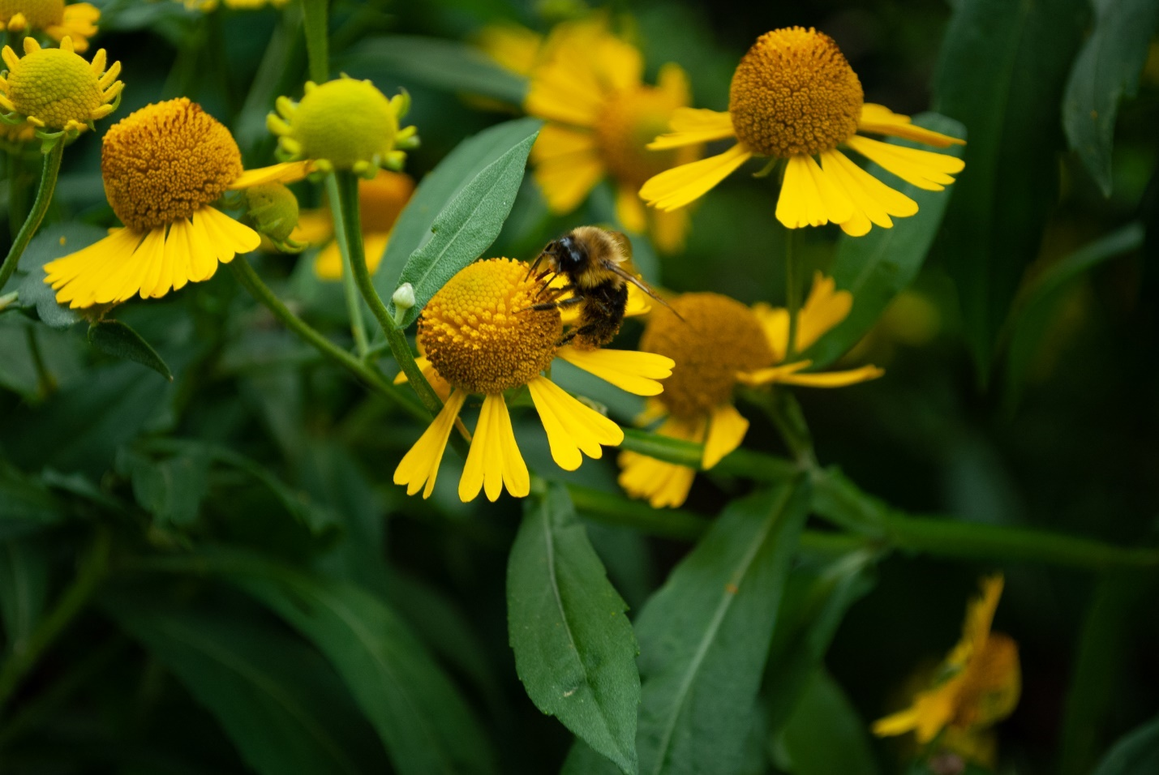
Photo credit: Clean Water MN. Native Bee Habitat.

Native Plant Sales

Facebook: Are you looking to buy native plants this spring? Check out Blue Thumb’s resource for upcoming sales and links to native plant nurseries. bluethumb.org/spring-native-plant-sales-in-minnesota/
Instagram: Are you looking to buy native plants this spring? Check out Blue Thumb’s resource for upcoming sales and links to native plant nurseries at the link in our bio. #CleanWater #PollinatorFriendly #NativePlants
Twitter: Are you looking to buy native plants this spring? Check out Blue Thumb’s resource for upcoming sales and links to native plant nurseries. bluethumb.org/spring-native-plant-sales-in-minnesota/ #CleanWater #PollinatorFriendly #NativePlants
Image: 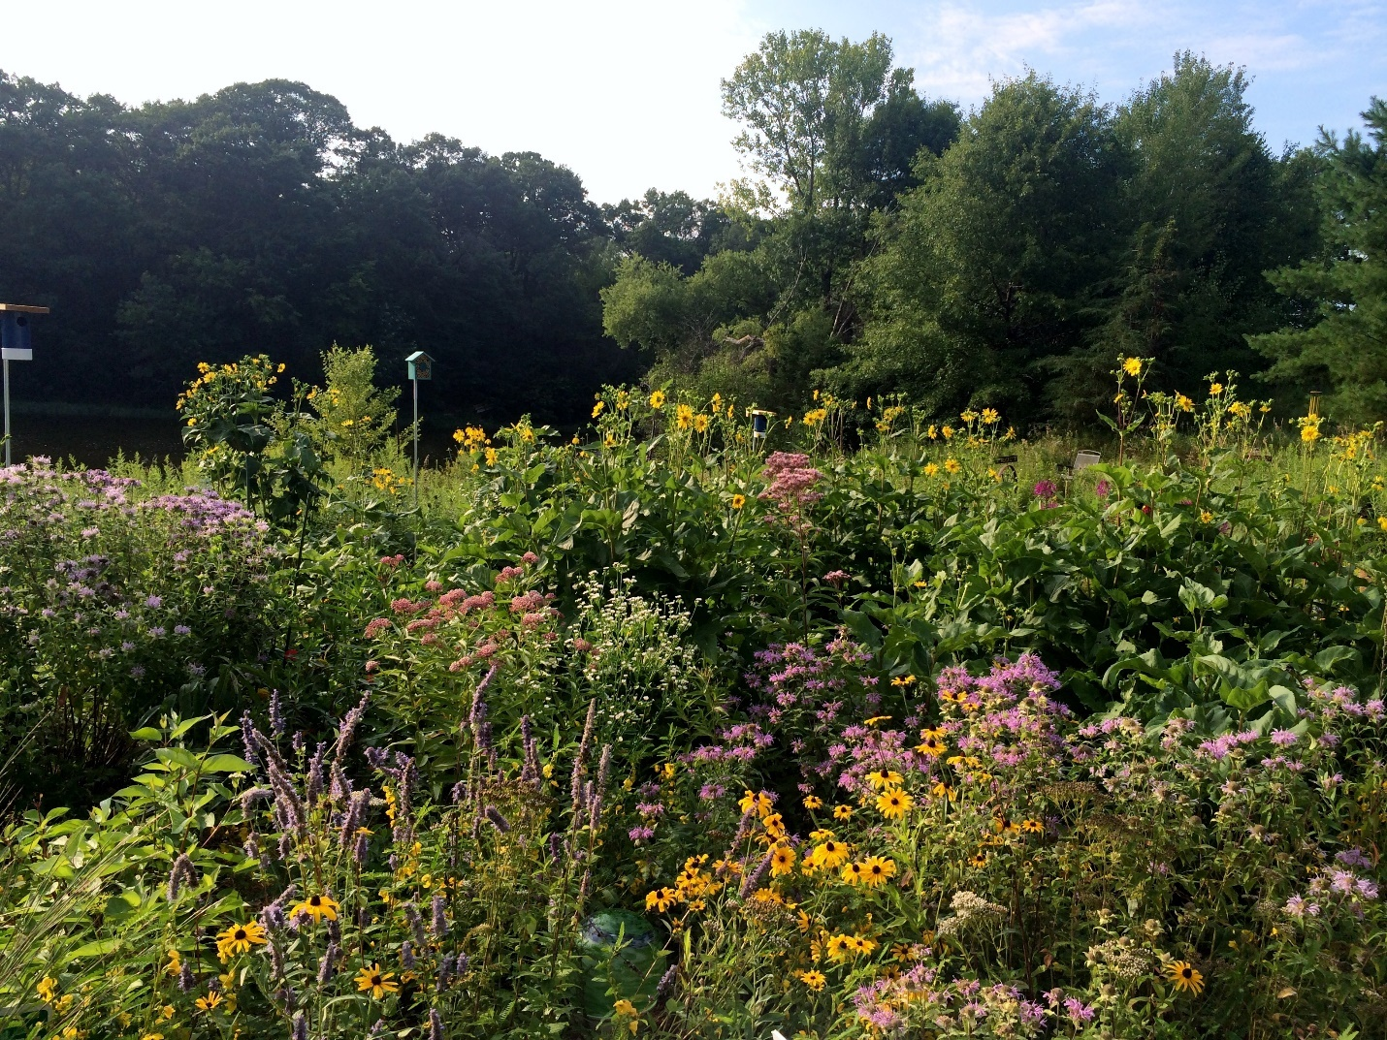
Photo credit: Clean Water MN. Native rain garden.

Lawns to Legumes

Facebook: Are you interested in protecting pollinators like the rusty patched bumble bee and the monarch butterfly? Lawns to Legumes gives cost-share grants of up to $400 to help cover the costs of planting pollinator-friendly yards. Learn more and apply by May 15 bluethumb.org/lawns-to-legumes/about/
Instagram: Are you interested in protecting pollinators like the rusty patched bumble bee and the monarch butterfly? Lawns to Legumes gives cost-share grants of up to $400 to help cover the costs of planting pollinator-friendly yards. Learn more and apply by May 15 at the link in our bio. #CleanWater #PollinatorFriendly #NativePlants
Twitter: Are you interested in protecting pollinators like the rusty patched bumble bee and the monarch butterfly? Lawns to Legumes gives cost-share grants to help cover the costs of planting pollinator-friendly yards. Apply at bluethumb.org/lawns-to-legumes/about/ #PollinatorFriendly
Image: 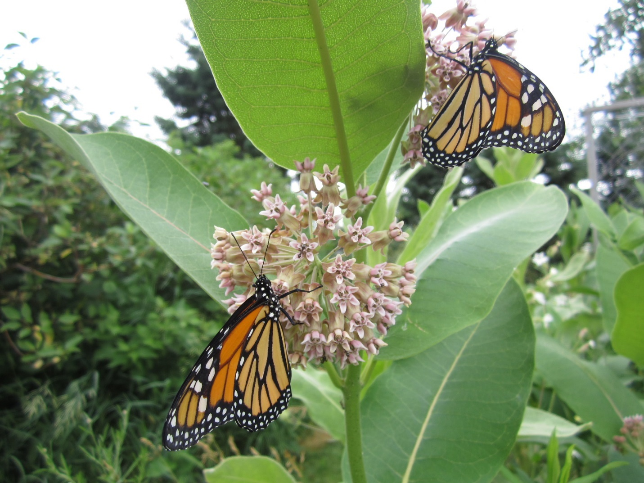
Photo credit: Clean Water MN. Pollinator plant.

Plant Finder

Facebook: Choosing the right plants for an outdoor space that have environmental benefits can be confusing, but using the online resource, Plant Finder, from Blue Thumb makes it easier by allowing you to search for plants based on color, bloom months, light, soil moisture requirements and more!
Instagram: Choosing the right plants for an outdoor space that have environmental benefits can be confusing, but using Blue Thumb’s online Plant Finder makes it easier by allowing you to search for plants based on color, bloom months, light, soil moisture requirements and more! Access the Plant Finder at the link in our bio.
Twitter: Choosing the right plants for an outdoor space that have environmental benefits can be confusing, but using Blue Thumb’s online Plant Finder makes it easier! Search for plants based on color, bloom months, light, soil moisture requirements and more! bluethumb.org/plants
Images: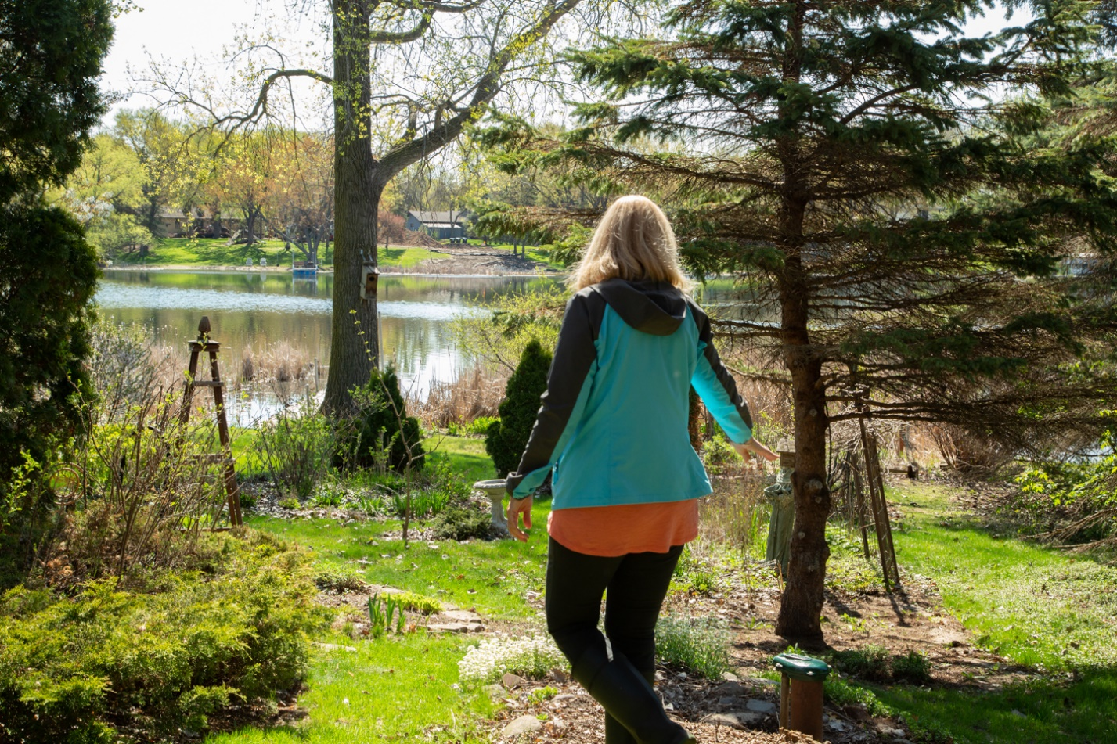
Photo credit: Clean Water MN. Pollinator Lawn.

Blue Thumb Workshops/Events

See Blue Thumb’s Workshops, Spring 2024 Media Kit: MEDIA PACKET | Blue Thumb Spring 2024 Workshops - Google Drive
Share Blue Thumb’s recent blog post: The Resilient Yard: One Space, Big Impact – Blue Thumb

