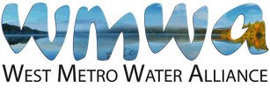

Earth Month and Adopt-a-Drain media kit

About stormwater education
This media kit is created to enhance education around water quality and stormwater management throughout WMWA territory and can be shared outside of WMWA territory. The article can be edited as needed to enhance water quality education. This media kit highlights Earth Month and includes directions for residents to clean up streets, improve water quality, and sign up for the Adopt-a-Drain program.

Resources to promote Earth Month and the Adopt-a-Drain program
Ways to educate the public about stormwater management:
- Use the sample newsletter article to share on your organization’s website or in your newsletters. These are editable so you can customize the length or message.
- Use the sample social media posts to share through your social media channels. These are editable so you can customize the message and website.
- Follow and reshare messages posted on the Hennepin County Environment and Energy social media channels: Hennepin Environment on Facebook, Hennepin Environment on Instagram, and @hennepinenviro on Twitter.
- Share the information and resources available on the Adopt-a-Drain website.

Contact
For more information about stormwater education and the Adopt-a-Drain program, contact:
Grace Barcelow, Conservation Specialist, grace.barcelow@hennepin.us.
Sample newsletter article – Earth Month and Adopt-a-Drain

April showers bring May flowers… and pollution to our lakes, rivers, and streams

Every April, Earth Month is celebrated by many communities and is the largest civic event on the planet, activating billions of people to care for the environment and take action for a brighter future. In Minnesota, April historically brings an abundance of rain. While the rain does help our environment in many ways, it also carries pollutants into our waters.
There is a common misconception that water runs into the storm drains on our streets and is filtered before it enters the environment. In reality, the heavy rains common in the spring wash the buildup of snow, trash, and pollutants from the wintertime directly into our lakes, rivers, and streams without any treatment.
Pollution from stormwater runoff is the most common and substantial threat Minnesota waters face to upholding healthy ecosystems. Water picks up pollutants like unnatural amounts of leaves and twigs, excess sediment like sand and dirt, salt from winter deicers, bacteria like E. Coli and other pet waste pollutants, gas and oil from cars, and more. This significantly affects water, causing growth of harmful algae, killing aquatic life, and contaminating our fish and drinking water sources. This is why it is imperative everyone is aware of steps they can take to reduce the pollution entering Minnesota’s beautiful waters.
In honor of Earth Month, to improve water quality, we are encouraging residents to sign up for the Adopt-a-Drain program. It is a simple, low time commitment action that can make a huge improvement in environmental health. For anyone who cleans their drain and reports it OR signs up for the program and reports a cleaning during Earth week (April 20 to April 30), Adopt-a-Drain is offering free t-shirts. Follow these four steps outlined by the Adopt-a-Drain website:
- Sign up: Sign up online to Adopt a Drain in your neighborhood at mn.adopt-a-drain.org.
- Keep your drain clear: Sweep leaves, trash, and other debris off the drain surface year-round.
- Track your impact: Estimate how much debris you collect and enter it into your online account so we can gauge the cumulative results of our work.
- Lead by example: Let friends and neighbors know about your commitment and, if they ask, tell them about small things they can do at home to prevent water pollution.
For questions on how to get involved in protecting water quality in your community, please contact Grace at grace.barcelow@hennepin.us.

Social media posts
Suggested hashtags: #EnvironmentalConservation #AdoptaDrain #CleanWater #Water #WaterQuality
To use images and graphics: right click on image and select Save as Picture

Spring Clean-up
Facebook: April showers bring May flowers... and pollution to our lakes, rivers, and streams. In honor of Earth Month, and the kickoff of warmer weather, we are encouraging residents to sign up for the Adopt-a-Drain program to help keep streets clean of debris that built up over the winter. It is a simple, low time commitment action that improves the health of our water, and consequently, plant, animal, and human life. Adopt-a-Drain is offering free t-shirts for anyone who cleans their drain and reports it OR signs up for the program and reports a cleaning during Earth week (April 20 to April 30). Learn more and sign up at adopt-a-drain.org. #AdoptaDrain #CleanWater
Instagram: April showers bring May flowers... and pollution to our lakes, rivers, and streams. In honor of Earth Month, and the kickoff of warmer weather, we are encouraging residents to sign up for the Adopt-a-Drain program to help keep streets clean of debris that built up over the winter. It is a simple, low time commitment action that improves the health of our water, and consequently, plant, animal, and human life. Adopt-a-Drain is offering free t-shirts for anyone who cleans their drain and reports it OR signs up for the program and reports a cleaning during Earth week (April 20 to April 30). Learn more and sign up at adopt-a-drain.org. #AdoptaDrain #CleanWater
Twitter: April showers bring May flowers... and pollution to our lakes, rivers, and streams. In honor of Earth Month, we are encouraging residents to sign up for the Adopt-a-Drain program. It is a simple, low time commitment action that improves the health of water. Learn more and sign up at adopt-a-drain.org. #AdoptaDrain #CleanWater
Image:
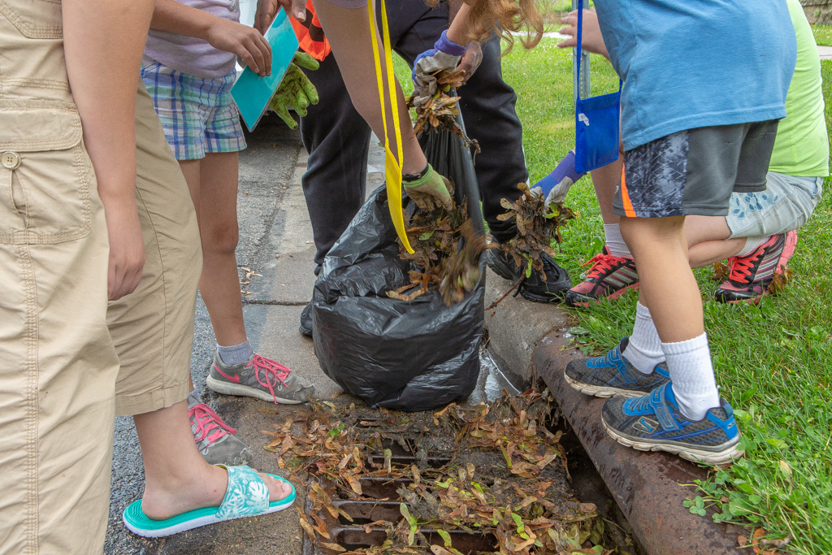
Photo credit: Clean Water MN. Cleaning up a storm drain.

