Maintain Your Lawn to Protect Rivers and Streams

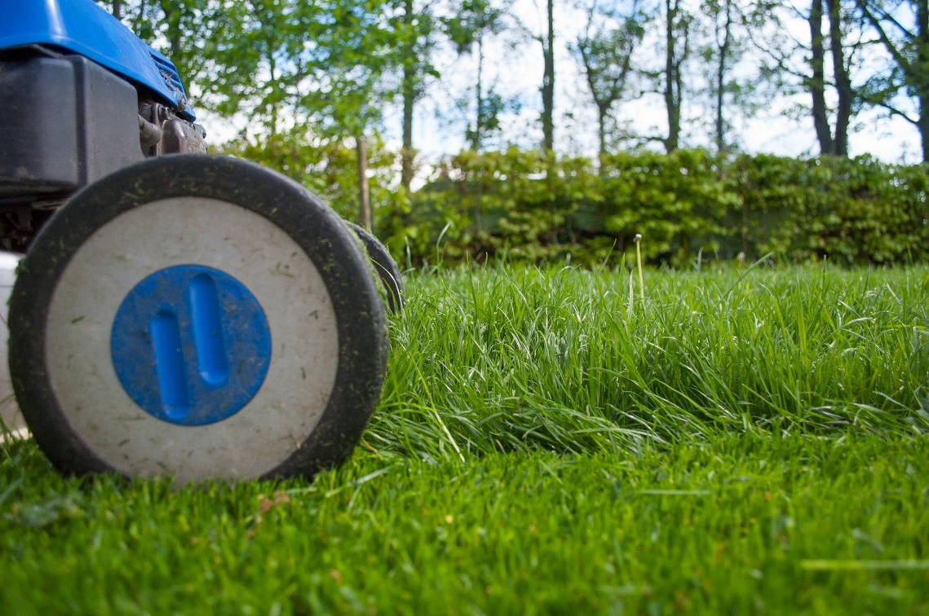
Many people like the look of a neatly mowed, bright green lawn. Plus, many communities and Home Owners Associations require residents to maintain their lawns to a certain standard. Traditional lawn maintenance depends on regular mowing, watering and chemical applications—most notably, fertilizers.
Lawn fertilizer contains nutrients, such as nitrogen and phosphorous, that encourage turfgrass to grow quickly. However, the fertilizer we put on our lawns also affects the health of our local rivers and streams.

What Lawn Fertilizer Does to Rivers and Streams
When it rains, excess fertilizer on your lawn and sidewalk is picked up by stormwater and washed down storm drains that lead directly to local rivers and streams.
The amount of nutrients introduced to a stream from lawn fertilizers and other sources is much more than a stream can naturally manage. Many stretches of local waterways are stressed by several factors—such as other pollutants, dams that interrupt a stream’s natural flow, in-stream habitat degradation and stream bank erosion. Excess fertilizer further throws off the stream ecosystem.
The same nutrients in fertilizers that encourage grass to grow cause algae in bodies of water to grow too. Spikes in algae harm water quality and suck oxygen from the water that fish and other aquatic life need to survive. These mucky, green “algae blooms” also detract from the natural beauty of our local streams and impact recreational opportunities like fishing and kayaking.
You may have heard about the “dead zone” in the Gulf of Mexico. Dead zones are areas in a body of water with oxygen levels so low that they cannot sustain life. Did you know that fertilizers used on Midwest agricultural fields are a major cause of the Gulf of Mexico dead zone? The fertilizers on farm fields run off into local waterways that feed into the Mississippi River and accumulate in the Gulf of Mexico. These fertilizers provide a feast for algae that eventually die off, deplete oxygen and kill fish.
While lawn fertilizers are not used to the same degree as agricultural inputs, we should keep in mind that the fertilizers we use locally have an impact on local streams as well as downstream waters.

Fertilizer Best Practices
If you’re using fertilizer on your lawn, there are a few things you can keep in mind to lessen the burden on rivers and streams.

Follow Product Instructions
Be sure to read the instructions on the fertilizer package and apply the right amount of product to your grass at the right time. More fertilizer does not make the product work better. In addition to hurting water quality in our rivers and streams, excess fertilizer can cause “fertilizer burn” and damage your grass.

Organic Fertilizer is Still Fertilizer
Synthetic fertilizers are manufactured while organic fertilizers are made from natural sources. Organic or not, treat all fertilizer products carefully. Organic fertilizer still contains nitrogen and phosphorus that affect the health of our waterways and should be used according to the instructions.

Sweep Excess Fertilizer Off Hard Surfaces
Fertilizer that falls on hard surfaces, such as driveways, sidewalks and curbs, are swiftly picked up by stormwater runoff and brought into nearby streams. Sweep excess fertilizer off hard surfaces to protect waterways.
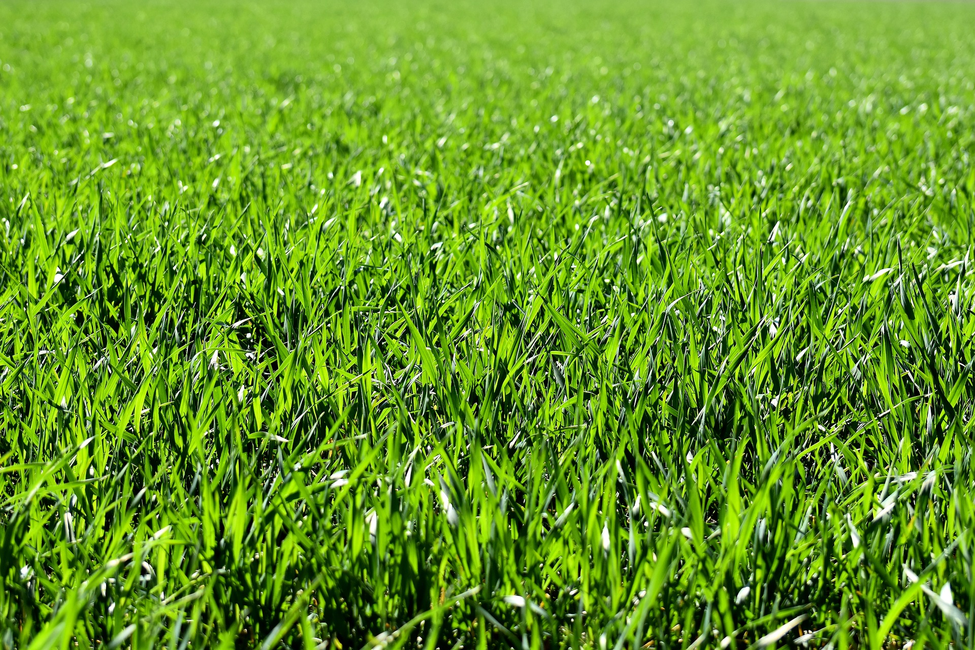

Take Care of Your Yard Naturally
Lawn care doesn’t have to involve the use of chemicals. Consider these tips for a healthy lawn and to limit your impact on local rivers and streams:
- Choose a grass better suited to our area. If you’re seeding new grass, select a hardier grass that requires less watering and fertilizer.
- Don’t mow too low. Mowing a lawn too short exposes surface roots and dries out the soil faster. As a general rule, try not to mow more than 1/3 of the height of the grass at a time.
- Focus on improving the health of your grass and soil over time instead of using large amounts of fertilizer as a quick fix.
- Use a mulching mower to help naturally fertilize lawns. Mulching mowers leave behind shredded grass clippings that act as compost to fertilize your lawn without adding chemicals.
- Dispose of lawn clippings and other yard waste properly. Do not dump anything along streams, wetlands, or in other natural areas.
- Consider native plant landscaping. This will reduce the amount of lawn on your property, requiring less fertilizer, watering and mowing. As another benefit to nearby streams, native plants filter out pollutants in runoff and infiltrate the water into the soil. Native plants also improve the local ecosystem by providing habitat for birds and butterflies.
- Have tolerance. “Weeds” like clover are actually good for your lawn as they help to fix nitrogen in the soil making it available for you grass to easily use. Clover flowers also provide food for native pollinators.
With this information in mind, you can maintain your lawn in a healthy way that protects the water quality of local rivers and streams. Remember clean, healthy water = vibrant, healthy communities!
For more environmentally-friendly landscaping tips, learn more about The Conservation Foundation’s Conservation@Home program at https://www.theconservationfoundation.org/conservation-home/

[Short Version or Summary, 121 words]
Lawn fertilizer contains nutrients, such as nitrogen and phosphorous, that encourage turfgrass to grow quickly. However, the fertilizer we put on our lawns also affects the health of our local rivers and streams. When it rains, stormwater picks up excess fertilizer on your lawn and sidewalk and brings it down storm drains that lead directly to local waterways. The same nutrients in fertilizers that encourage grass to grow cause algae in bodies of water to grow too. Algae harms water quality and fish, detracts from our waterway’s natural beauty, and can even impact recreational opportunities like fishing and kayaking. If using fertilizer on your lawn, be sure to follow the product instructions and sweep excess fertilizer off hard surfaces like sidewalks.

