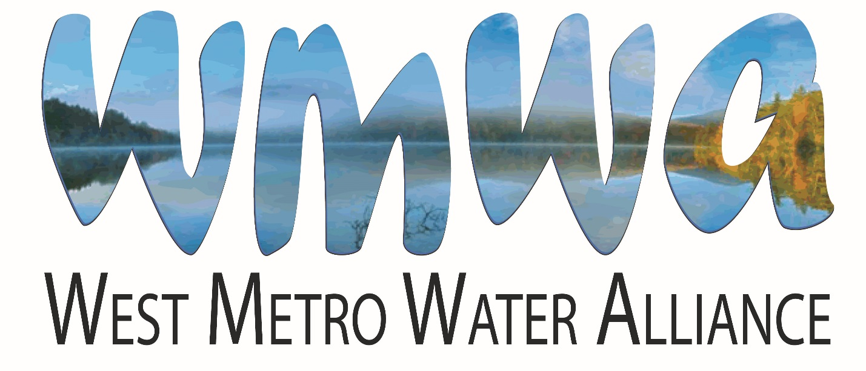

2021 Annual Report

Background
In 2006 the Shingle Creek and West Mississippi Watershed Management Commission’s Education and Public Outreach Committee (EPOC) invited the Education Committee of the Bassett Creek Watershed Management Commission to partner in developing joint education and outreach activities. Since that time this voluntary partnership has grown to include the Elm Creek Watershed Management Commission, the Three Rivers Park District, Hennepin County Department of Environment and Energy, and the Freshwater Society. The WMOs are designated as “members,” the latter three organizations as “partners.”
This alliance, the West Metro Water Alliance (WMWA), grew from a recognition that the individual organizations have many common education and public outreach goals and messages that could be more efficiently and effectively addressed and delivered collaboratively and on a wider scale.
Meetings
WMWA meets monthly, as needed, on the second Tuesday, virtually via Zoom. Member representatives include Laura Jester, Bassett Creek WMC Administrator; Doug Baines, Commissioner, Elm Creek WMC; Nico Cantarero, Stantec, Dayton, Elm Creek WMC; Marta Roser, Robbinsdale, Shingle Creek WMC. and Ben Scharenbroich and Amy Riegel, Plymouth, Shingle Creek, Bassett Creek and Elm Creek WMCs. Other attendees include Sharon Meister, Watershed PREP Educator; Diane Spector, Stantec/Wenck Associates, serves as technical support for WMWA, and Amy Juntunen, JASS, serves as administrative support. In 2021 eleven meetings were held. All WMWA member Commissioners and city staff are welcome to attend meetings.
The WMWA Program
Goals of the WMWA program are to:
▪ Inform the public about the watershed organizations and their programs.
▪ Provide useful information to the public on priority topics.
▪ Engage the public and encourage positive, water-friendly behaviors.
▪ Help member cities meet MS4 permit requirements regarding education.
Three informational pieces have been developed by WMWA to support these goals. The 10 Things You Can Do Brochure targets the general public. The brochure is distributed at all venues where the Commissions or member cities have a presence and also in the Watershed PREP classrooms. It is also available on the websites of the WMO member cities. In 2019 the 10 Things brochure was updated and reprinted in partnership with Hennepin County.
The Maintain Your Property the Watershed Friendly Way handbook targets small businesses, multi-family housing properties, and common interest communities such as homeowners’ associations. It contains tips for specifying and hiring turf and snow maintenance contractors, and includes checklists for BMP inspections.
The Residential Snow and Ice Care brochure is an educational piece designed to inform citizens of the chloride pollution problem and ways to reduce salt use. The Commercial Snow and Ice brochure is designed to inform HOAs, property managers and commercial applicators of the chloride pollution problem and ways to reduce salt use.
In 2021 WMWA began development of three new flyers to address MS4 permit education needs on the topics of Pet Waste, Water Softener Chlorides, and Deicer Chlorides. These flyers will be completed in 2022 and provided to member cities for distribution and addition to website/social media.
Watershed PREP and Community Events
Watershed PREP is a program of WMWA and stands for Protection, Restoration, Education, and Prevention. 2021was the ninth year of the program. Two contract educators with science education backgrounds are shared between the member watersheds. The focus of the program is two-fold - to present water resource-based classes to fourth grade students and to provide education and outreach to citizens, lake associations, other civic organizations, youth groups, etc. Goals of the program are 1) to have audiences gain a general understanding of watersheds, water resources and the organizations that manage them, and 2) to have audiences understand the connection between actions and water quality and water quantity. The ultimate goal is to make this program available to all fourth graders in the four WMWA watersheds and to other schools as contracted.
Fourth Grade Program. Three individual lessons meeting State education standards have been developed. Lesson 1, What is a Watershed and Why do We Care?, provides an overview of the watershed concept and is specific to each school's watershed. It describes threats to the watershed. Lesson 2, Water Cycle - More than 2-dimensional!, describes the movement and status of water as it travels through the water cycle. Lesson 3, Stormwater Walk, investigates movement of surface water on school grounds.
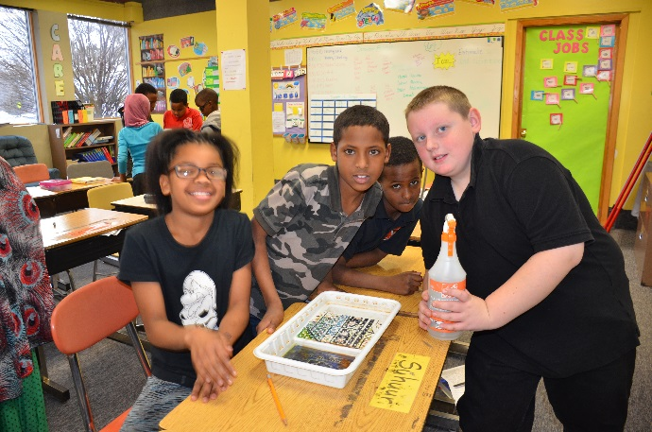 | In 2021, due to COVID, only one classroom presentation was given in the fall. More classes have been scheduled for spring 2022.  Educators created a video of the presentation in 2020 for parents and teachers to use.  Due to COVID there were no community outreach events staffed by educators in 2021.

In 2021, Educator Sharon Meister tendered her resignation. Staff analyzed the hours dedicated to the project by past Educators and created a new Professional Services Agreement. In November 2021, Jessica Sahu Teli was contracted as the new Watershed PREP Educator. Sahu Teli is a wetland scientist and educator with a B.S. in aquatic biology/limnology and is currently pursuing her Masters of Environmental Science degree.

Updated Work Plan
In 2021 the WMWA Work Plan was updated to reflect current practices. The updated Work Plan included the following major revisions:
- Added an equity statement affirming the group’s commitment to environmental justice for all and outreach to historically underrepresented groups.
- Revised the general educational goals for non-single family property owners and managers to focus solely on providing information and guidance on appropriate BMPs.
- Removed educational goals for developers as cities were seen as being the most appropriate points of contact with these stakeholders.
- Removed educational goals for training city staff, as those are the responsibility of the cities.
- Removed educational goals for agricultural property owners and operators as Hennepin County staff have taken on that role acting as the County Soil and Water Conservation District.
- Added a key educational goal for all the stakeholders to “understand the relationship between climate and water quality and water quantity.”
- Revised the plan to replace references to the Hennepin County website with the WMWA website.
- Eliminated Measuring and Monitoring Public Awareness as a major task. One of WMWA’s first activities was sponsoring a professional opinion poll in the four watersheds regarding knowledge and behaviors. WMWA does not expect to repeat that poll due to cost but will build measuring and evaluating into individual activities.
- Strengthened the Communication and Information Sharing activity to incorporate the website and social media.
- Eliminated the Develop and Coordinate Regional or Countywide Activates task. Early on WMWA had sponsored a series of workshops for broader participation but found it to be an inefficient use of time and resources. The group will focus on spreading information about existing activities sponsored by other groups.
WMWA’s 2020 and 2021 budgets reflect these activities and were approved by the members on January 8, 2019 and January 14, 2020, respectively. The budgets are included in this report as Appendix C.
Special Project
In November 2020, Minnesota Pollution Control Agency approved the new 2020 MS4 general permit. WMWA member cities must apply for the new permit by April 15, 2021. Included in the new permit are several education requirements.
The 2021 Special Project was dedicated to helping member cities meet the new MS4 permit education requirements. The new permit requires cities to distribute educational materials or equivalent outreach to stakeholders at lease once per year regarding the impacts of deicing salt and pet waste on surface waters and ways to reduce these impacts.
In 2021 WMWA Special Project funds were approved for the creation of three one-page flyers to address pet waste, deicing chlorides, and water softener chlorides, as well as associated landing pages with further information on the WMWA website. Participating members created the content and hired Taurus Moon Graphic Design to complete the flyer design. The three flyers will be completed and available to member cities in early 2022.

WMWA Coordinator Position
In the fourth quarter of 2019, members re-evaluated spending on the current Special Project. Looking forward to the needs of 2020 and the future, members voted to use Special Project funding for 2020 to hire a WMWA Coordinator as members did not have enough time to dedicate to certain upcoming projects, such as a survey to inform the update of the Work Plan, planned for 2020. An applicant was hired for the position beginning January 1, 2020.
Due to difficulties with COVID, the applicant was unable to start the position in 2020. The new Educator may be able to take on some of the responsibilities this position was created for in 2022.

Resilient Yard Workshops
Due to COVID, Workshops were not held in-person. Metro Blooms did create an online webinar format of the workshop. WMWA did not sponsor workshops in 2021, though they are available to member cities through Metro Blooms directly.
Winter Maintenance Training
In 2021, Winter Maintenance Training workshops were hosted via webinar by Plymouth on October 27 for the road applicator training and November 5 for the parking lot and sidewalk training, with about 60 attendees at each training. Attendees learned how to adjust the use of salt de-icing products to be effective without overuse
WMWA Website
The WMWA website www.westmetrowateralliance.org serves as a repository for documents and information for access by member cities and citizens, lists local events WMWA is participating in and/or otherwise promoting, stores Watershed PREP information for schools, and collects information for the Pledge to Plant campaign and newsletter subscriptions.
The website had 689 unique visitors engaged in 786 individual sessions with an average of 1.14 pages viewed per session for a total of 1,092 page views on the website in 2021. The website metrics can be found in Appendix B
2021 Marketing Activity
In May 2016 WMWA created a social media campaign for the Pledge to Plant campaign and WMWA in general on Facebook and Twitter. As of December 31, 2020, the WMWA Twitter page had been discontinued As of December 31, 2021, the Facebook page had 204 followers and 258 posts resulting in 3,109 engagements and 287 shares.

To learn more about WMWA, contact:
Diane Spector, Stantec, 763.252-6880, diane.spector@stantec.com
or Amy Juntunen, JASS, 763.553.1144, amy@jass.biz

Appendix
Appendix A – Watershed PREP / Educator Activity

Table 1. 2021 schools and students participating in Lesson 1: What is a Watershed?
 | Date | School | School District | City | Watershed | Classes | Students
1 | 10/26 | Rice Lake | Osseo | Maple Grove | Elm | 4 | 80
 |  |  |  |  | Total: | 4 | 80

Educators created a video of the presentation in 2020 for parents and teachers to use in distance learning during COVID. The video can be found on YouTube at https://www.youtube.com/watch?v=bq4zKMfc-pQ&t=763s. The video had 222 views as of December 31, 2021

Watershed PREP
Lesson 1: What is a Watershed and Why Do We Care?
Lesson 2: Project WET, The Incredible Journey
Year | Lesson 1  Classes | Lesson 1  Students | Lesson 2  Classes | Lesson 2  Students
2013 | 35 | 870 | 9 | 230
2014 | 73 | 1875 | 5 | 160
2015 | 118 | 3106 | 27 | 859
2016 | 107 | 2850 | 20 | 524
2017 | 125 | 3358 | 38 | 1072
2018 | 143 | 3593 | 69 | 1755
2019 | 103 | 2681 | 58 | 1516
2020 | 20 | 572 | 10 | 256
2021 | 4 | 80 | 0 | 0
Total | 728 | 18985 | 236 | 6372

Appendix B – Website/Social Media Activity
Likes grew in 2021 to a total of 172 likes and 204 followers. In 2021 there were 188 posts resulting in 3,109 engagements and 287 shares. The maximum post reach was 83 and maximum post engagements was 47.

Appendix C – Budget

 |  | 2019 | 2020 |  |  |  | 2021 |  |  |  | 2022
 |  | Balance | Budget | Revenue | Expense | Balance | Budget | Revenue | Expense | Balance | Budget
Admin/Tech Services |  | $401 | $12,000 | $12,000 | $7,647 | $4,754 | $12,000 | $12,000 | $9,299 | $7,455 | $12,000
 | Routine tasks, website, social media, meetings, etc
Special Projects |  | $9,199 | 8,000 | 4,000 | 2,482 | 10,717 | 8,000 | 4,000 | 0 | 14,717 | 8,000
Watershed Prep |  | $4,964 | 16,000 | 8,000 | 3,214 | 9,750 | 16,000 | 4,000 | 315 | 13,435 | 16,000
Resilient Yards |  |  | Billed directly to cities |  |  |  | Billed directly to cities
 | Metro Blooms workshops
TOTAL |  | $14,564 | $42,000 | $24,000 | $13,343 | $25,221 | $36,000 | $20,000 | $9,614 | $35,607 | $36,000

